SPECIAL FILM SCREENING EVENT
4.11.14 - ORLANDO, FL AREA

A FEATURE DOCUMENTARY FILM about the 23.5 million Americans living in long-term recovery, and the emerging public recovery movement that will transform how alcohol and other drug problems are dealt with in our communities.

DATE: SHOWTIMES:

WHERE:

TICKETS:
April 11th, 2014

7:00 - Doors Open
7:30 - Feature Film: The Anonymous People 8:50 - Special Q&A Panel Featuring:
Greg Williams Film’s Director

Wayne Densch Performing Arts Center 201-203 S. Magnolia Avenue
Sanford Florida 32771

$12 Proceeds to Benefit
N.O.W. Matters More Foundation http://tinyurl.com/AnonymousPeopleFL
“The best doc on addiction you’ll ever see. It’s thrilling, stunning, terrifying, heartbreaking & ultimately, simply staggering.”
- Kristen Johnston
FILM TRAILER:

FACEBOOK.COM/THEANONYMOUSPEOPLEMOVIE

FOLLOW @THEANONYMOUSPPL

HOSTED BY:
SUPPORT PROVIDED BY:

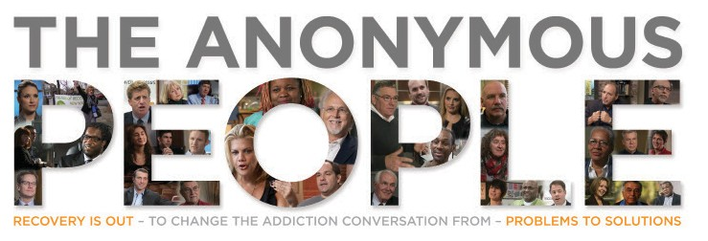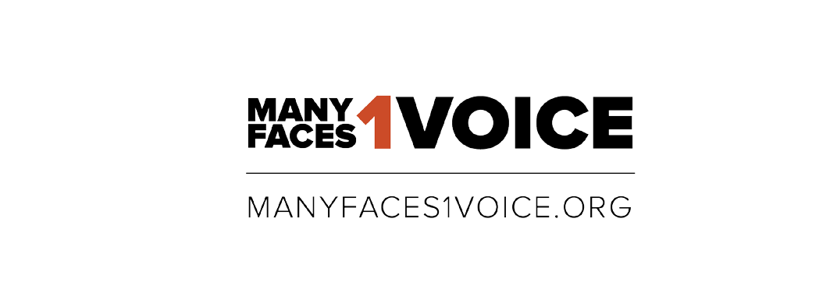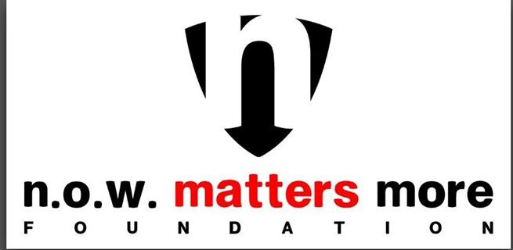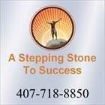

http://nowmattersmore.org http://www.asteptosuccess.com/

